1.Create user with name Techie and provide sudo access to user.
Useradd techie
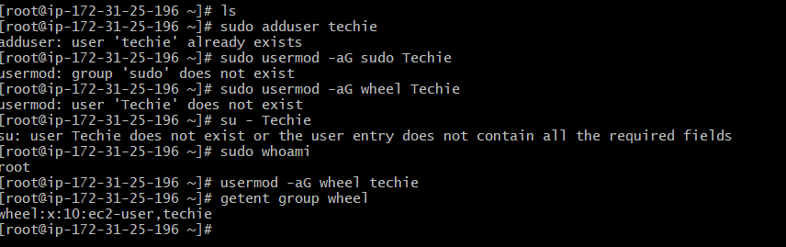
2.Navigate to the home directory.
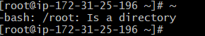
3.Create a new directory.
Mkdir : created directory
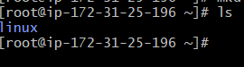
4.List the contents of a directory.
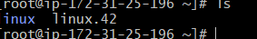
5. Change the current directory.
Cd : change to current directory
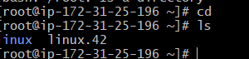
6. Create a new empty file.
Touch : created the file
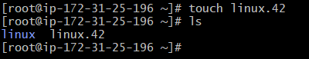
7. View the contents of a file.
Cat : view the content of file
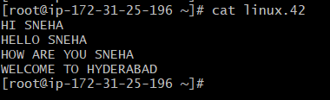
8. Copy a file to another location.
Cp linux.42 /linux.422 : copy the file
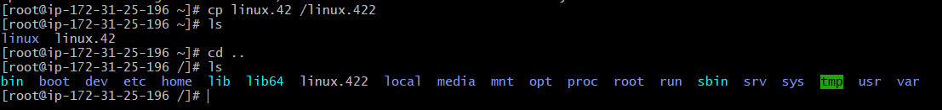
9.Move a file to another location.
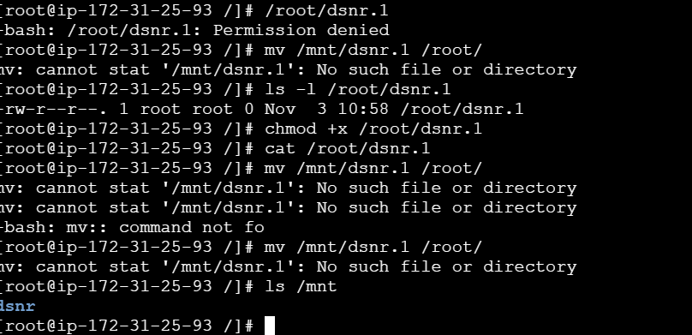
10.Rename a file.
Mv : rename the file
11.Delete a file.
Rm -rf : delete the file
12.Grant or revoke permissions on a file or directory.
Ls -l : grant a file
Given the premissions to file
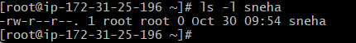
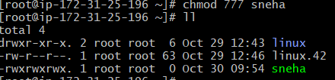
13.View the current date and time.
Date : show the current date and time
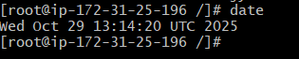
14.Check the system uptime.
Uptime : this commend used to show uptime of system
15. View the running processes.
Ps -ef : show the running processes
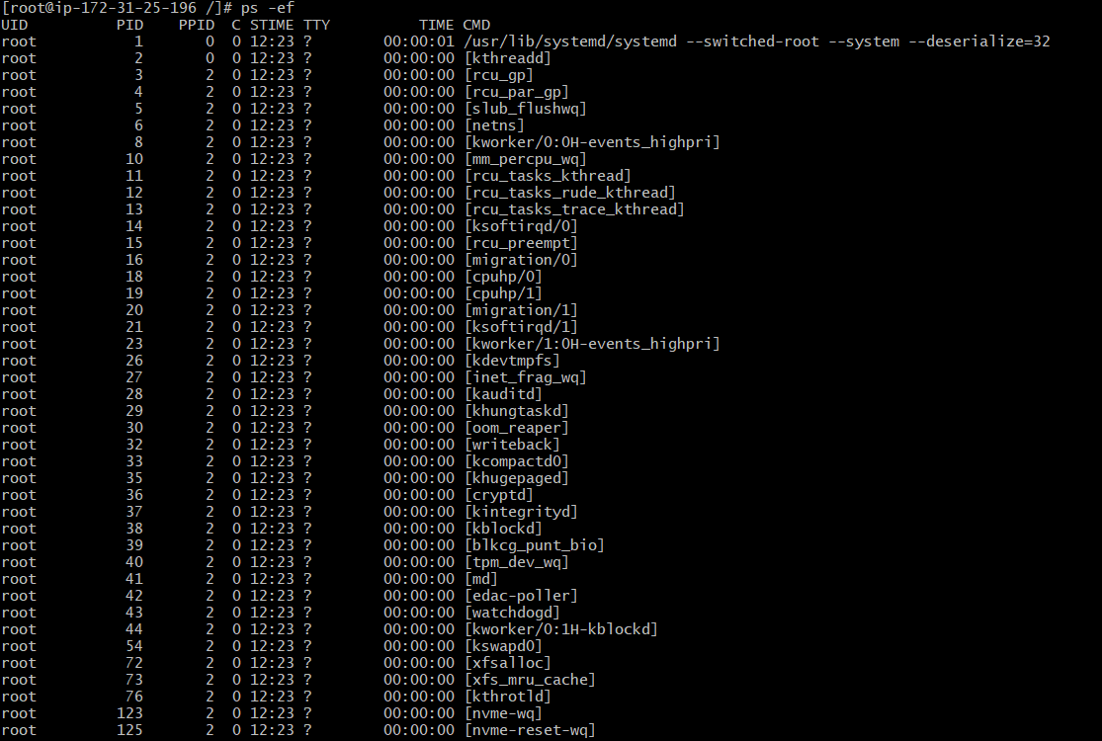
16. Kill a running process.
Kill - <PID> : kill the processing ID
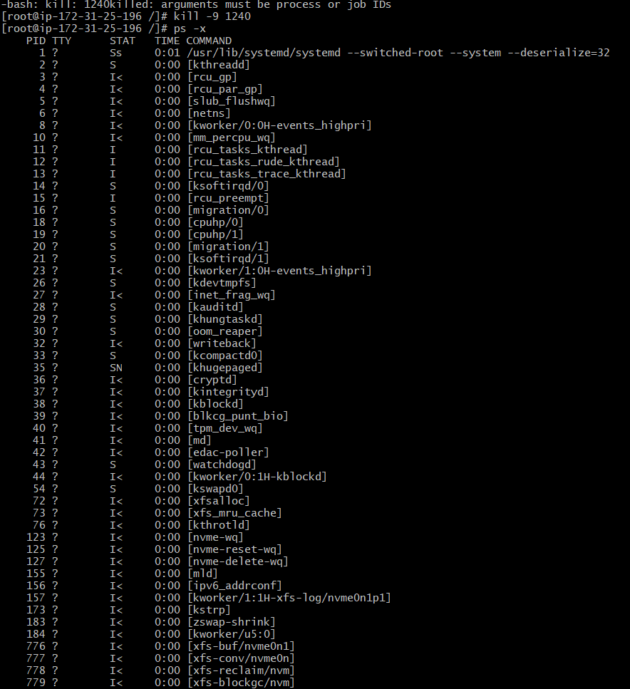
17. Install a package using the package manager (e.g., apt or yum).
Sudo yum install httpd
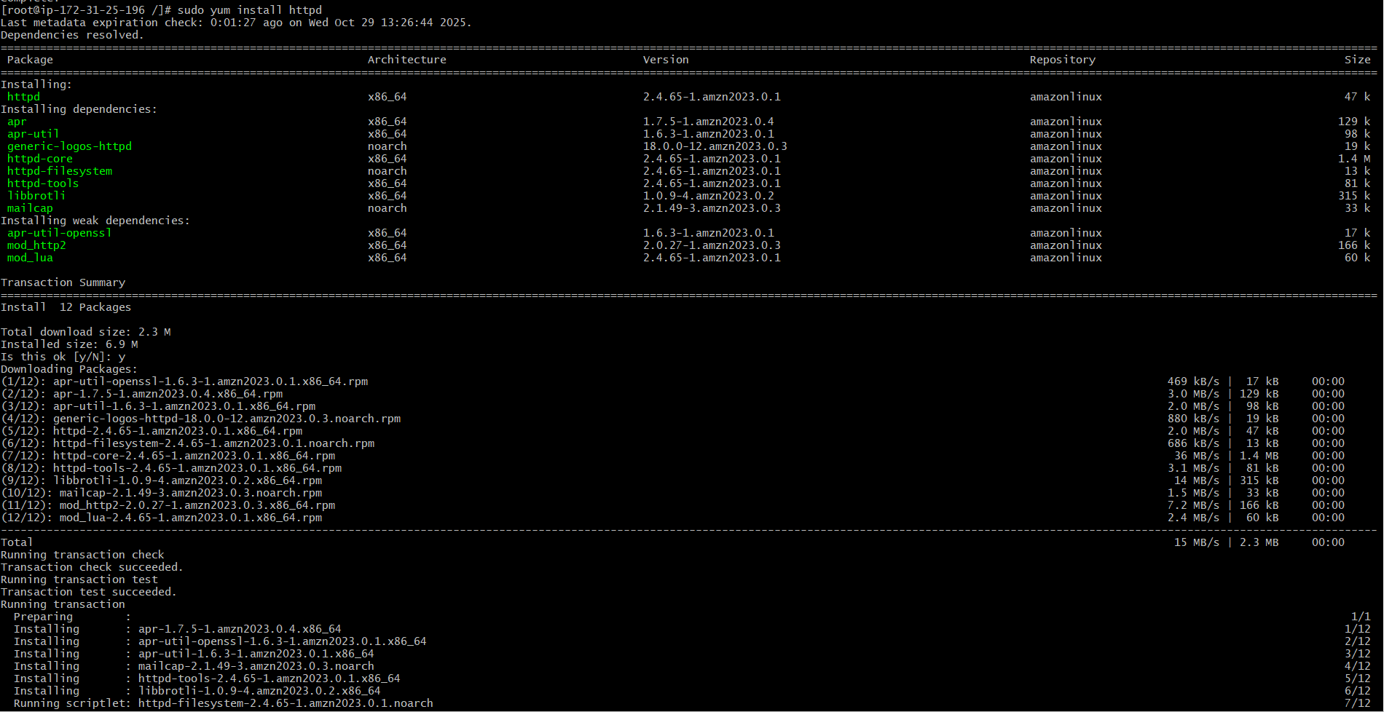

18.Update the system packages.
Yum update : update the prckages
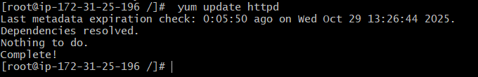
19.Create a symbolic link.
In -s : creating symbolic link
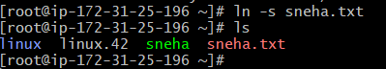
20. Search for files using the find command.
Find / -type f -name “sneha.txt” : find the file
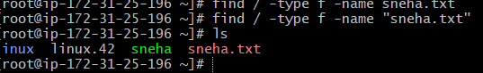
21.Compress and decompress files using tar.
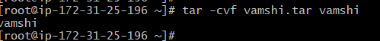
22.Monitor system resources with top or htop.
Top : it will help tomonitor the resources
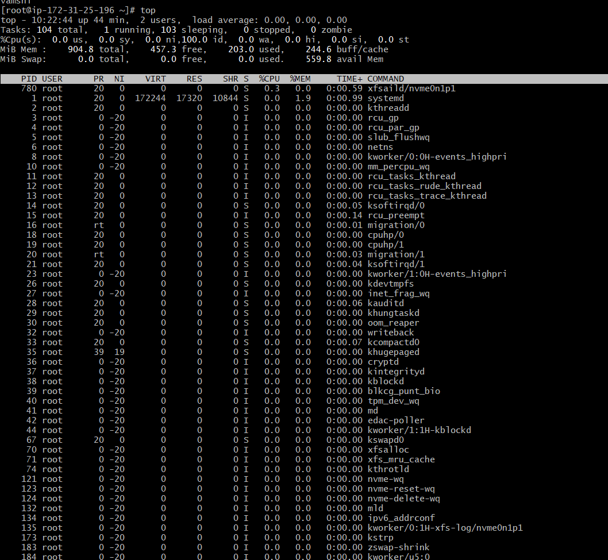
23.Create and manage user groups.
Groupadd techie-grp : this commend will help to creat the group
Usermod -Ag : this commend is help to manage

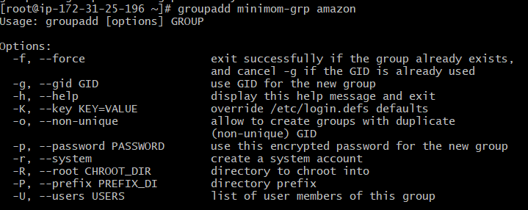
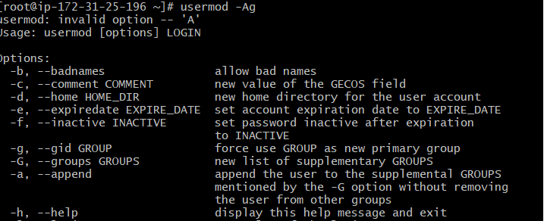

24.Set up SSH password less authentication.
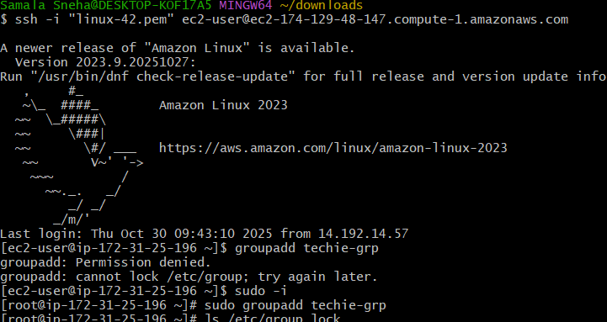
- Monitor log files using tail or grep.
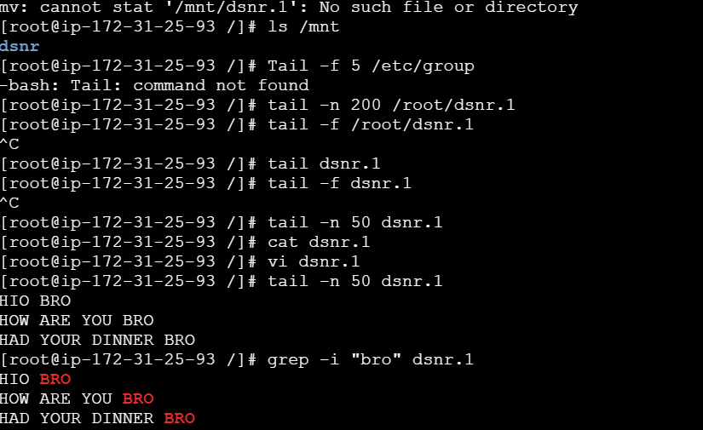

26. Set up a web server (e.g., Apache or Nginx).
Install nginx
Start
Status
Change port http to 80
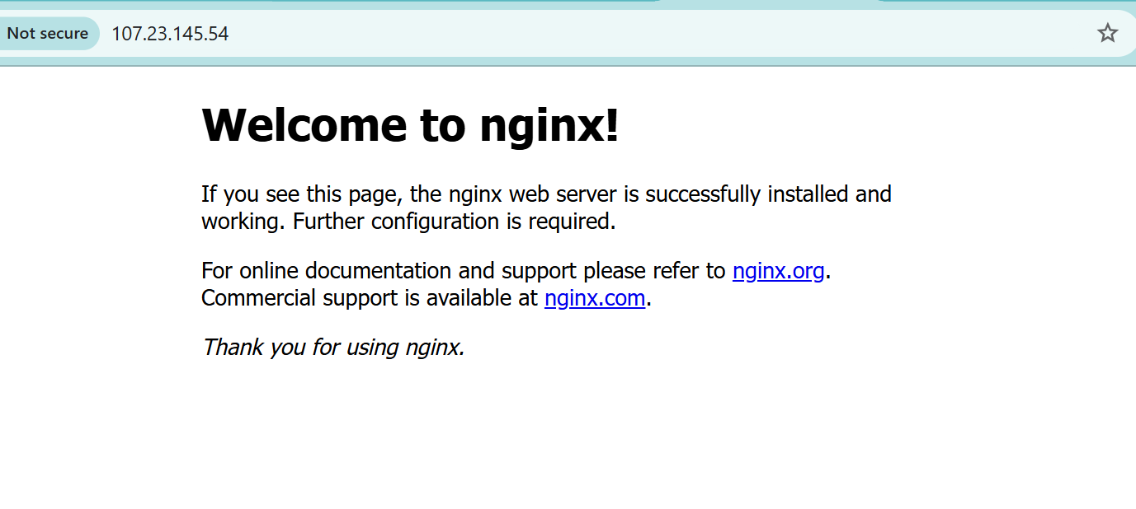
- Configure and secure a MySQL Database.
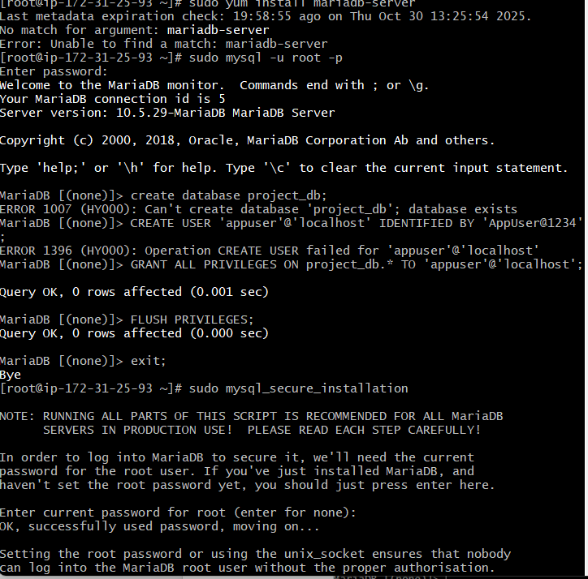
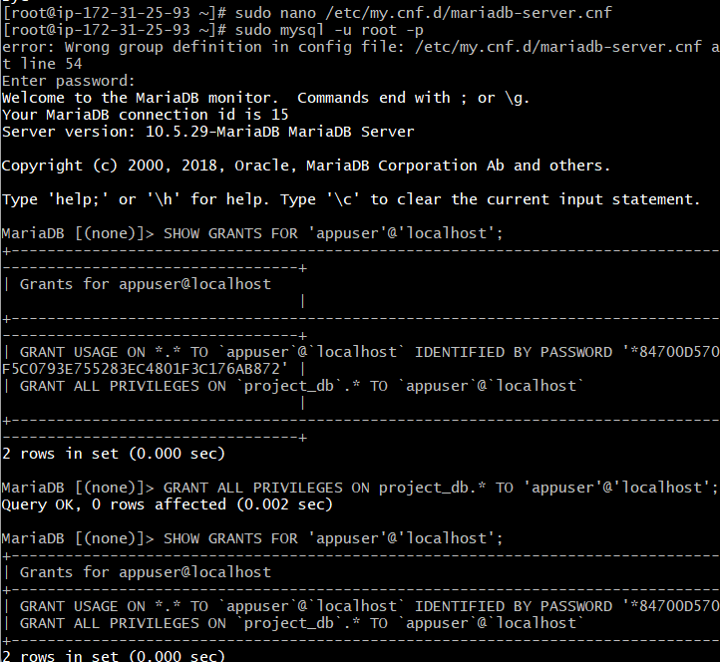
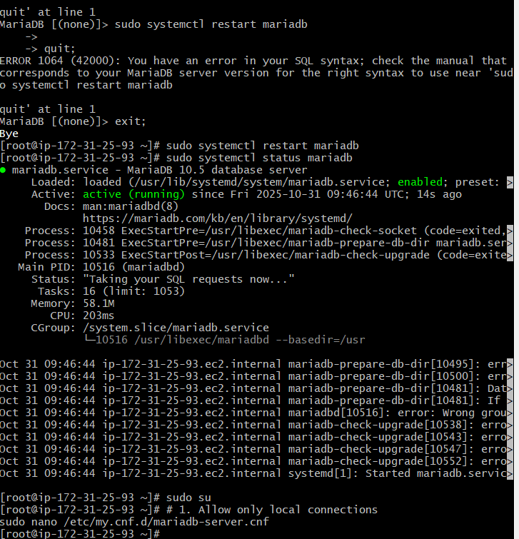
28. Set up a Application Server (e.g.,Apache Tomcat)
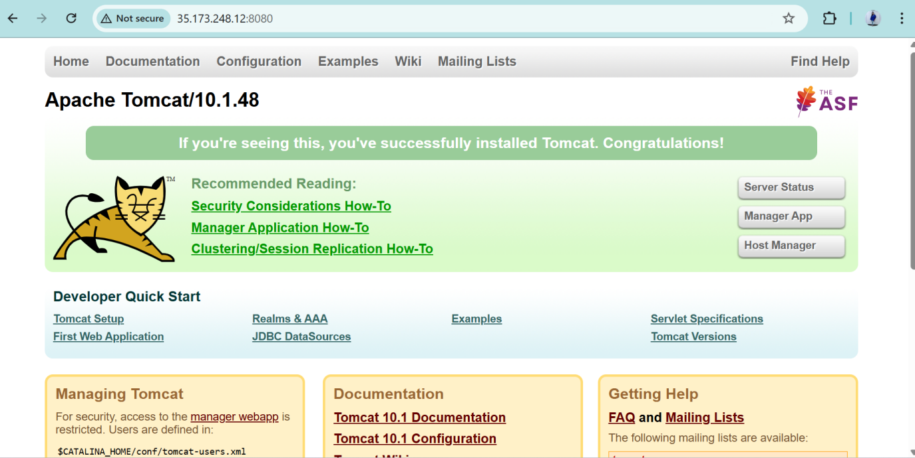
- create a service file for Apache Tomcat.(Should execute by using systemtctl command)
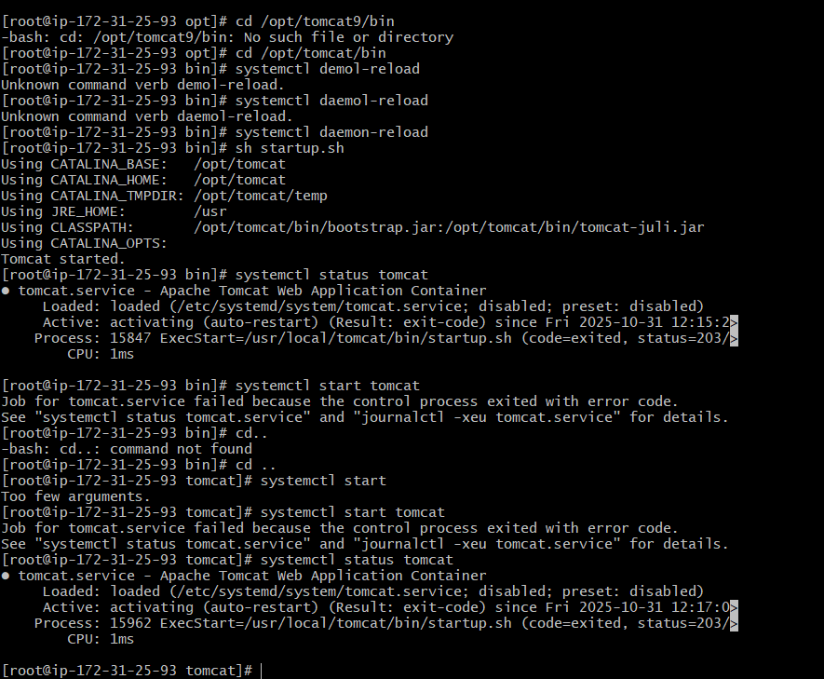
- Print specific columns from a delimited file.
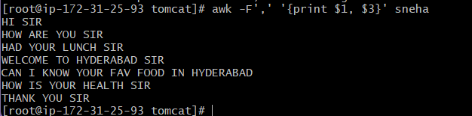
- Filter and print lines based on a specific pattern or condition.
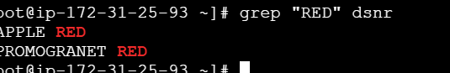

- Calculate and print the average, sum, or other statistics of a column.
33. Perform string manipulation, such as extracting substrings or changing case.
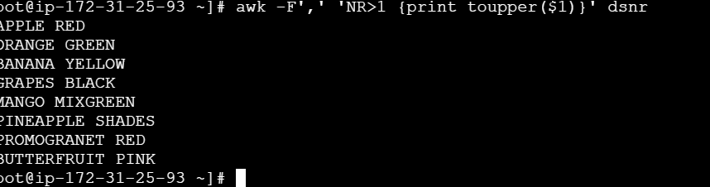
34. Count the occurrences of a specific pattern in a file.
35. Sort lines based on a specific field or column.
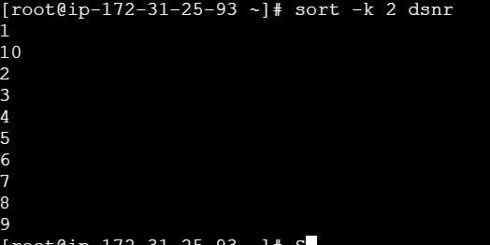
36. Merge multiple files based on a common field or column.
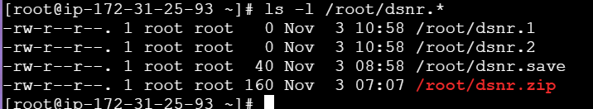
37. Substitute text in a file using search and replace.
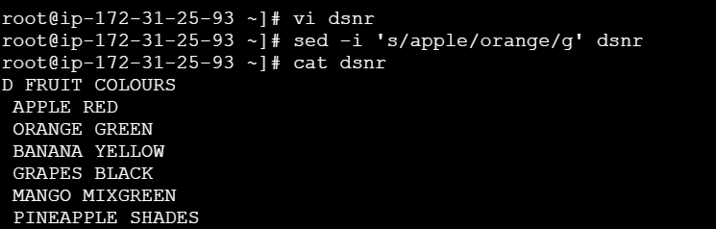
38. Delete specific lines based on a pattern or line number.
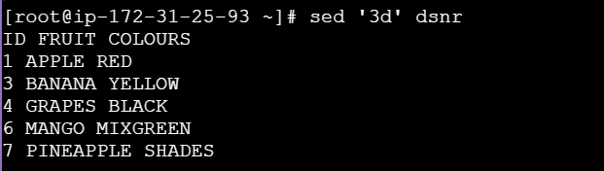
39. Append or insert text before or after a specific pattern or line.
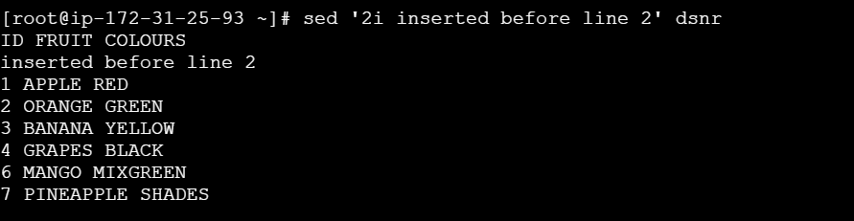
40. Print only specific lines from a file.
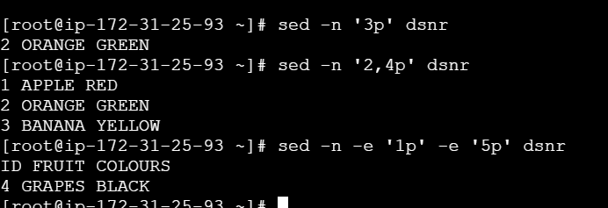
- Copy file from linux to windows machine
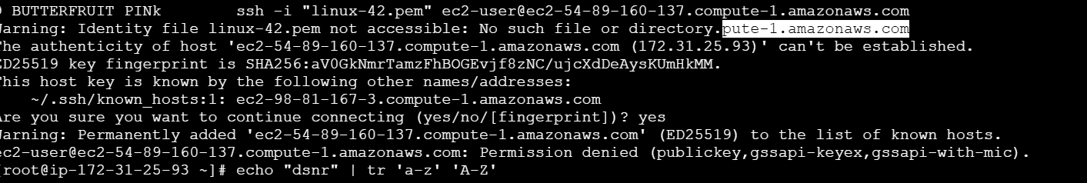

- 5 use cases for AWK and 5 use cases for sed
